

**VIRGINIA COMMONWEALTH UNIVERSITY**

**Statistical analysis and modelling (SCMA 632)**

**A6b-** **Time Series Analysis**

**(Part – B)**

**ADHYAYAN AMIT JAIN**

**V01109421**

**Date of Submission: 25-07-2024**

**CONTENTS**

|  |  |  |
| --- | --- | --- |
| **Sl. No.** | **Title** | **Page No.** |
| **1.** | Introduction | **1** |
| **2.** | Results | **5** |
| **3.** | Interpretations | **5** |
| **4.** | Implications | **23** |
| **5.** | Recommendations | **25** |
| **6** | Codes | **27** |
| **7.** | References | **34** |

**Advanced Time Series Analysis of Commodity Prices with VAR and VECM Models**

**INTRODUCTION**

In this assignment, we delve into the advanced analysis of commodity price data using sophisticated econometric techniques, specifically Vector Autoregression (VAR) and Vector Error Correction Models (VECM). Our focus is on a diverse set of commodities, including Oil, Sugar, Gold, Silver, Wheat, and Soybean. This analysis leverages data sourced from the World Bank’s Pink Sheet, a reputable repository of global commodity prices.Commodity prices are pivotal indicators in economic analysis, reflecting supply and demand dynamics, market expectations, and macroeconomic conditions. The ability to model and forecast these prices is essential for various stakeholders, including policymakers, investors, and businesses. By applying VAR and VECM models, this assignment aims to uncover both short-term and long-term relationships among commodity prices, providing insights into their interconnected behavior.

**Vector Autoregression (VAR)** is a powerful tool for capturing the linear interdependencies among multiple time series. It allows us to understand how each commodity’s price influences and is influenced by the prices of other commodities over time. VAR models are particularly useful when the data exhibits interdependencies but does not necessarily exhibit co-integrating relationships.

**Vector Error Correction Models (VECM)**, on the other hand, extend VAR models to account for co-integration among the time series. Co-integration indicates that while individual time series may be non-stationary, they share a common long-term equilibrium relationship. VECM models are adept at analyzing these long-term relationships and correcting short-term deviations from this equilibrium. They provide a framework for understanding how the commodities return to their equilibrium state over time.The data for this analysis is derived from the World Bank’s Pink Sheet, which provides comprehensive and up-to-date commodity price information. This data serves as a crucial foundation for our modeling efforts, allowing for an accurate and meaningful analysis of price dynamics across the selected commodities.

In summary, this assignment employs VAR and VECM models to explore the intricate relationships between commodity prices. By doing so, it seeks to enhance our understanding of how these prices interact, both in the short term and in the long term, thereby offering valuable insights into market behavior and trends.

**OBJECTIVES**

The primary objectives of this assignment are as follows:

1. **Model Short-term Dynamics with VAR:**
   * Utilize Vector Autoregression (VAR) to capture and analyze the interdependencies among the prices of selected commodities.
   * Understand how each commodity’s price influences and is influenced by the prices of other commodities over time.
   * Determine the optimal lag length for the VAR model to accurately reflect the relationships among the commodities.
2. **Identify Long-term Relationships with VECM:**
   * Apply the Vector Error Correction Model (VECM) to explore potential long-term equilibrium relationships among the commodities.
   * Test for co-integration among the time series to assess whether the commodities share a common long-term trend.
   * Estimate the number of co-integrating relationships (r) and analyze how deviations from equilibrium are corrected over time.
3. **Forecast Future Commodity Prices:**
   * Generate forecasts for future commodity prices using both the VAR and VECM models.
   * Compare and contrast the forecasting performance of the two models to determine which provides more accurate predictions.
   * Visualize and interpret the forecasted values to assess potential future trends in commodity prices.
4. **Conduct Statistical Tests and Validation:**
   * Perform stationarity tests (e.g., Augmented Dickey-Fuller test) to ensure that the data series meet the assumptions required for VAR and VECM modeling.
   * Validate the models through diagnostic checks and robustness tests to ensure the reliability of the results.
5. **Provide Insights and Implications:**
   * Analyze the findings to draw insights about the behavior and interaction of commodity prices.
   * Discuss the implications of these insights for stakeholders such as policymakers, investors, and businesses.
   * Offer recommendations based on the analysis to aid in decision-making and strategic planning.

**BUSINESS SIGNIFICANCE**

The analysis of commodity prices through VAR and VECM models holds substantial business significance across several sectors. Understanding the dynamics and relationships among commodity prices is crucial for various stakeholders, including investors, businesses, policymakers, and analysts. Here’s how this analysis can impact different aspects of business and economic decision-making:

1. **Investment Decisions:**
   * **Informed Investment Strategies:** Investors can use the insights from VAR and VECM models to make informed decisions regarding portfolio allocation. By understanding the interdependencies and long-term relationships between commodity prices, investors can better anticipate price movements and adjust their investment strategies accordingly.
   * **Risk Management:** Analyzing the forecasted trends and volatility of commodity prices helps in assessing potential risks. Investors can use this information to hedge against unfavorable price movements and manage financial risks more effectively.
2. **Business Planning and Strategy:**
   * **Cost Management:** Companies that rely on commodities as raw materials (e.g., manufacturing and agriculture) can benefit from understanding price forecasts to plan their procurement strategies. Accurate forecasts enable businesses to manage costs, negotiate better contracts, and budget effectively.
   * **Pricing Strategies:** Firms in the commodity supply chain can use insights from the analysis to set competitive pricing strategies. Understanding how prices of related commodities influence each other helps in formulating pricing strategies that align with market conditions.
3. **Supply Chain Management:**
   * **Inventory Management:** Businesses involved in the trading or processing of commodities can use price forecasts to optimize inventory levels. By anticipating price changes, companies can make strategic decisions about stock levels and timing of purchases to minimize costs and maximize profitability.
   * **Supplier Relationships:** Insights into price trends can improve negotiations with suppliers. Businesses can leverage forecast data to negotiate favorable terms and mitigate the impact of price fluctuations on their supply chain.
4. **Policy and Regulation:**
   * **Economic Policy Formulation:** Policymakers can use the findings from this analysis to understand the economic impact of commodity price fluctuations. This understanding aids in the formulation of policies that stabilize markets, manage inflation, and support economic growth.
   * **Regulatory Measures:** The analysis helps in designing regulatory measures to address volatility in commodity markets. Policymakers can implement interventions that mitigate extreme price swings and ensure market stability.
5. **Strategic Decision-Making:**
   * **Market Entry and Expansion:** Companies considering entry into new markets or expansion in existing markets can benefit from understanding commodity price trends. Insights into price relationships and forecasts assist in evaluating market potential and making strategic expansion decisions.
   * **Competitive Analysis:** Businesses can use the analysis to monitor competitors and anticipate their pricing and supply chain strategies. Understanding how commodity prices impact competitors helps in developing competitive strategies and gaining a market edge.

In summary, the business significance of analyzing commodity prices through VAR and VECM models lies in its ability to provide actionable insights for investment, operational, strategic, and policy-related decisions.

**RESULTS AND INTERPRETATIONS**

**Python Language**

### **Complete Analysis of Time Series Analysis Code**

#### ****1. Importing Libraries****

import os

import pandas as pd

import numpy as np

from statsmodels.tsa.stattools import adfuller

from statsmodels.tsa.vector_ar.vecm import coint_johansen, VECM

from statsmodels.tsa.api import VAR

import matplotlib.pyplot as plt

**Description:**

* os: Provides functions to interact with the operating system, though it's not used in this script.
* pandas (pd): A powerful library for data manipulation and analysis, especially with DataFrames.
* numpy (np): Provides support for numerical operations and mathematical functions.
* adfuller: Function to perform the Augmented Dickey-Fuller (ADF) test, used for testing stationarity of time series data.
* coint_johansen: Function to perform Johansen’s co-integration test.
* VECM: Class for fitting Vector Error Correction Models, which handle non-stationary data with co-integration.
* VAR: Class for fitting Vector Autoregressive Models, used when there’s no co-integration.
* matplotlib.pyplot (plt): Used for creating static, interactive, and animated visualizations in Python.

**Purpose:** These libraries are essential for handling data, performing statistical tests, fitting models, and visualizing results.

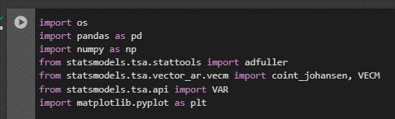

#### ****2. Loading the Dataset****

df = pd.read_excel('pinksheet.xlsx', sheet_name="Monthly Prices", skiprows=6)

**Description:**

* Reads the Excel file pinksheet.xlsx, specifically from the sheet "Monthly Prices", and skips the first 6 rows to adjust for headers or metadata.

**Purpose:** To load the commodity price data into a DataFrame df for further processing and analysis.

**Interpretation:** Initial step to bring the data into a Python environment, making it ready for cleaning and analysis.



#### ****3. Data Preprocessing****

df.rename(columns={df.columns[0]: 'Date'}, inplace=True)

df['Date'] = pd.to_datetime(df['Date'].astype(str) + '01', format='%YM%m%d')

print(df.info())

**Description:**

* df.rename(columns={df.columns[0]: 'Date'}, inplace=True): Renames the first column to 'Date' for clarity.
* df['Date'] = pd.to_datetime(df['Date'].astype(str) + '01', format='%YM%m%d'): Converts the 'Date' column from a string to a datetime object, appending '01' to ensure a complete date (assuming data is monthly and the day is always 01).
* print(df.info()): Prints a summary of the DataFrame to verify changes.

**Purpose:** To standardize the date format and ensure the DataFrame has the correct column names and data types.

**Interpretation:** Preparing the date column for time series analysis, ensuring that the data is correctly formatted and suitable for further steps.

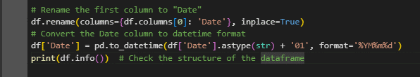

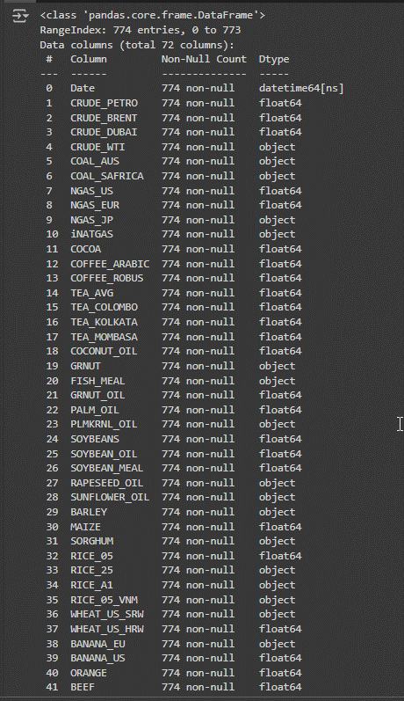

#### ****4. Selecting and Cleaning Data****

commodity = df[['Date', 'CRUDE_BRENT', 'SOYBEANS', 'GOLD', 'SILVER', 'UREA_EE_BULK', 'MAIZE']]

commodity.columns = commodity.columns.str.strip().str.lower().str.replace(' ', '_').str.replace('(', '').str.replace(')', '')

print(commodity.info())

**Description:**

* commodity = df[['Date', 'CRUDE_BRENT', 'SOYBEANS', 'GOLD', 'SILVER', 'UREA_EE_BULK', 'MAIZE']]: Selects relevant columns related to commodity prices.
* commodity.columns = commodity.columns.str.strip().str.lower().str.replace(' ', '_').str.replace('(', '').str.replace(')', ''): Cleans column names by removing spaces, converting to lowercase, and replacing special characters with underscores.
* print(commodity.info()): Prints a summary of the cleaned DataFrame.

**Purpose:** To isolate the columns of interest and clean the column names for consistency and ease of reference.

**Interpretation:** Ensuring that only relevant data is used and that column names are standardized for better code readability and maintenance.

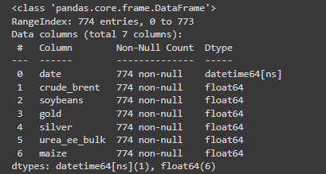

#### ****5. Removing Date Column for Analysis****

commodity_data = commodity.drop(columns=['date'])

**Description:**

* Removes the 'date' column from the DataFrame commodity, leaving only the commodity price data.

**Purpose:** To prepare the data for time series modeling by focusing solely on the variables of interest (commodity prices).

**Interpretation:** The 'date' column is not needed for statistical analysis and modeling; thus, it is excluded from commodity_data.



#### ****6. Testing for Stationarity****

columns_to_test = commodity_data.columns

non_stationary_count = 0

stationary_columns = []

non_stationary_columns = []

for col in columns_to_test:

adf_result = adfuller(commodity_data[col])

p_value = adf_result[1]

print(f"\nADF test result for column: {col}\n")

print(f"Test Statistic: {adf_result[0]}")

print(f"P-value: {p_value}")

print(f"Critical Values: {adf_result[4]}")

if p_value > 0.05:

non_stationary_count += 1

non_stationary_columns.append(col)

else:

stationary_columns.append(col)

print(f"\nNumber of non-stationary columns: {non_stationary_count}\n")

print(f"Non-stationary columns: {non_stationary_columns}\n")

print(f"Stationary columns: {stationary_columns}")

**Description:**

* Initializes lists and counters to keep track of stationary and non-stationary columns.
* Iterates over each column to perform the Augmented Dickey-Fuller (ADF) test.
* Extracts p-value and other statistics, and determines stationarity based on a common threshold (p-value > 0.05).
* Categorizes columns into stationary and non-stationary based on the p-value.

**Purpose:** To check whether each time series is stationary, which is a prerequisite for many time series models. Non-stationary series might need differencing or other transformations.

**Interpretation:** Stationarity is critical for modeling. Non-stationary columns are identified and will need to be addressed to ensure accurate modeling.

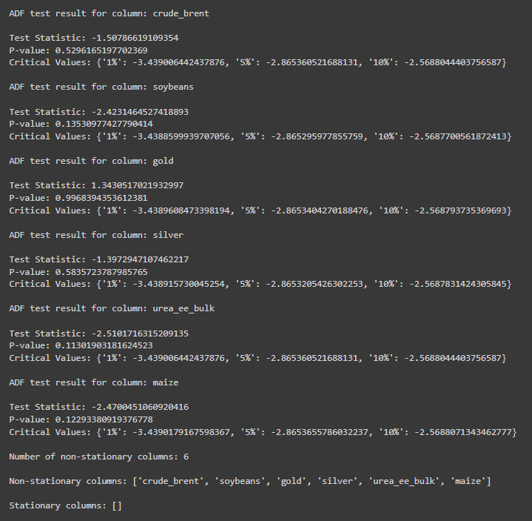

#### ****7. Performing Co-Integration Test****

johansen_test = coint_johansen(commodity_data, det_order=0, k_ar_diff=1)

print("\nJohansen Test Results:\n")

print(f"Eigenvalues:\n{johansen_test.eig}\n")

print(f"Trace Statistic:\n{johansen_test.lr1}\n")

print(f"Critical Values (5% level):\n{johansen_test.cvt[:, 1]}\n")

**Description:**

* Performs Johansen's co-integration test to determine the number of co-integrating relationships among the time series.
* Outputs eigenvalues, trace statistics, and critical values for the test.

**Purpose:** To assess if there are long-term equilibrium relationships between the time series, which is essential for applying VECM.

**Interpretation:** Johansen's test helps identify the number of co-integrating vectors. The results guide the selection of the VECM model or indicate if VAR should be used instead.

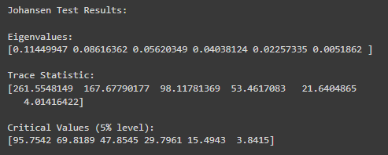

#### ****8. Estimating and Forecasting with VECM****

r = 2 # Replace with the actual number from the test results

if r > 0:

vecm_model = VECM(commodity_data, k_ar_diff=1, coint_rank=r, deterministic='co')

vecm_fitted = vecm_model.fit()

print(vecm_fitted.summary())

print("Alpha Coefficients:\n", vecm_fitted.alpha)

print("Beta Coefficients:\n", vecm_fitted.beta)

print("Gamma Coefficients:\n", vecm_fitted.gamma)

forecast = vecm_fitted.predict(steps=24)

forecast_df = pd.DataFrame(forecast, index=pd.date_range(start=commodity_data.index[-1], periods=25, freq='M')[1:], columns=commodity_data.columns)

forecast_df.plot(figsize=(10, 5))

plt.title('VECM Forecast')

plt.xlabel('Time')

plt.ylabel('Values')

plt.show()

else:

**Description:**

* If co-integration exists (r > 0), fits a Vector Error Correction Model (VECM) with specified parameters.
* Prints the model summary and coefficients (alpha, beta, gamma).
* Forecasts future values for 24 periods and plots the forecasted data.

**Purpose:** To model the short-term dynamics and long-term relationships among co-integrated variables. Forecasting provides insights into future trends based on historical data.

**Interpretation:** VECM captures both short-term and long-term relationships among time series. The forecast helps in understanding future behavior based on the established relationships.

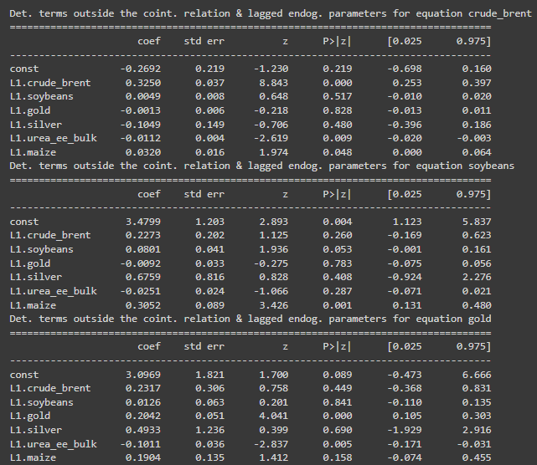

#### ****9. Estimating and Forecasting with VAR****

var_model = VAR(commodity_data)

var_fitted = var_model.fit(maxlags=10, ic='aic')

print(var_fitted.summary())

for col in commodity_data.columns:

granger_result = var_fitted.test_causality(causing=col, caused=[c for c in commodity_data.columns if c != col])

print(f"Granger causality test for {col}:\n", granger_result.summary())

var_forecast = var_fitted.forecast(var_fitted.y, steps=24)

var_forecast_df = pd.DataFrame(var_forecast, index=pd.date_range(start=commodity_data.index[-1], periods=25, freq='M')[1:], columns=commodity_data.columns)

var_forecast_df.plot(figsize=(10, 5))

plt.title('VAR Forecast')

plt.xlabel('Time')

plt.ylabel('Values')

plt.show()

**Description:**

* If no co-integration is found, fits an Unrestricted Vector Autoregression (VAR) model.
* Summarizes the VAR model and conducts Granger causality tests for each variable to identify causal relationships.
* Forecasts future values for 24 periods and plots the forecasted data.

**Purpose:** To model the dynamics among time series without assuming co-integration. Granger causality helps determine which variables influence others.

**Interpretation:** The VAR model captures interdependencies among variables, and Granger causality tests reveal causal relationships. Forecasting with VAR provides predictions based on the interactions among variables.

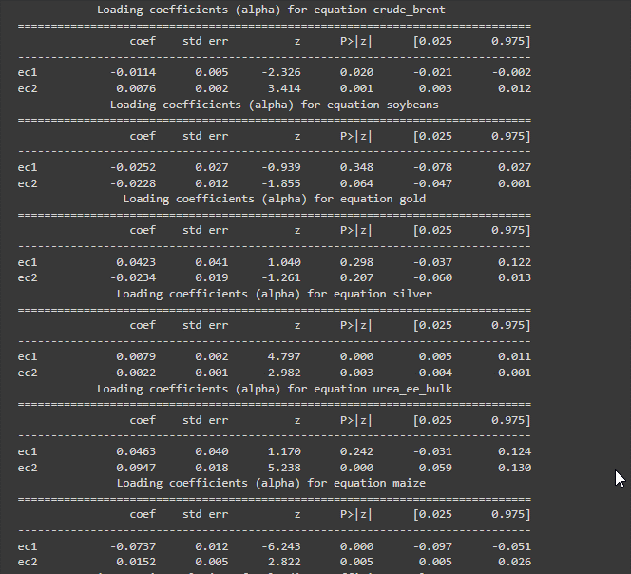

### **Summary**

This script performs a comprehensive time series analysis on commodity price data, covering:

1. **Data Loading and Preprocessing**: Importing data, renaming columns, and converting dates for accurate analysis.
2. **Stationarity Testing**: Using ADF tests to ensure that time series data is stationary.
3. **Co-Integration Testing**: Applying Johansen's test to determine the existence of long-term relationships among commodities.
4. **Model Fitting and Forecasting**:
   * **VECM**: When co-integration exists, capturing both short-term dynamics and long-term relationships.
   * **VAR**: When no co-integration is present, analyzing interdependencies and forecasting based on historical data.

**Visualizations**: The code also includes plotting forecasts to visually interpret future trends.

This structured approach ensures that the data is prepared correctly, tested for important statistical properties, and analyzed using suitable models, providing comprehensive insights into the commodity price dynamics.

**R Language**

### **Step-by-Step Analysis of Time Series Analysis Code in R**

#### ****1. Set Working Directory and Load Necessary Libraries****

r

setwd('D:\\#YPR\\VCU\\Summer Courses\\SCMA\\Assignments\\A6b') # Set the working directory to the location of your files

getwd() # Verify the current working directory

**Description:**

* setwd('D:\\#YPR\\VCU\\Summer Courses\\SCMA\\Assignments\\A6b'): Sets the working directory to the specified path, which is where the data file and any output files will be located.
* getwd(): Checks and prints the current working directory to ensure it is correctly set.

**Purpose:** To specify and verify the directory where the files are located, ensuring that file paths are correct for subsequent operations.

**Interpretation:** The working directory is crucial for file management in R, ensuring that the script can read from and write to the correct locations.

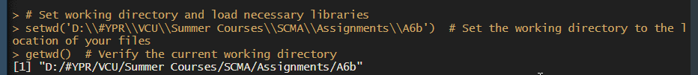

#### ****2. Install and Load Necessary Packages****

r

if (!require(readxl)) install.packages("readxl")

if (!require(dplyr)) install.packages("dplyxl")

if (!require(janitor)) install.packages("janitor")

if (!require(urca)) install.packages("urca")

if (!require(vars)) install.packages("vars")

library(readxl) # For reading Excel files

library(dplyr) # For data manipulation

library(janitor) # For cleaning column names

library(urca) # For unit root and cointegration tests

library(vars) # For VAR and VECM modeling

**Description:**

* Installs packages if they are not already installed.
* Loads the required libraries:
  + readxl: For reading Excel files.
  + dplyr: For data manipulation tasks.
  + janitor: For cleaning column names.
  + urca: For performing unit root and co-integration tests.
  + vars: For VAR and VECM modeling.

**Purpose:** To ensure that all necessary packages are available and loaded into the R environment for the analysis.

**Interpretation:** Loading the libraries is necessary for utilizing their functions and performing various analyses on the time series data.

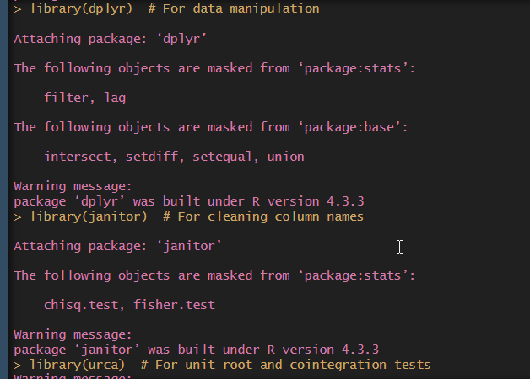

#### ****3. Load and Preprocess the Dataset****

df <- read_excel('pinksheet.xlsx', sheet = "Monthly Prices", skip = 6)

**Description:**

* Reads the Excel file pinksheet.xlsx from the "Monthly Prices" sheet, skipping the first 6 rows to bypass headers or metadata.

**Purpose:** To load the dataset into a DataFrame df for further analysis.

**Interpretation:** Loading the data prepares it for cleaning and analysis by bringing it into the R environment.

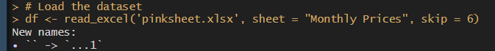

colnames(df)[1] <- 'Date'

df$Date <- as.Date(paste0(df$Date, "01"), format = "%YM%m%d")

str(df) # Check the structure of the dataframe

**Description:**

* colnames(df)[1] <- 'Date': Renames the first column to "Date" for clarity.
* df$Date <- as.Date(paste0(df$Date, "01"), format = "%YM%m%d"): Converts the 'Date' column to a Date object by appending '01' to the string to ensure it represents the first day of the month.
* str(df): Prints the structure of the DataFrame to verify changes.

**Purpose:** To standardize the date format and confirm that the DataFrame has the correct column names and data types.

**Interpretation:** Preparing the date column ensures that it is in the appropriate format for time series analysis, making the data suitable for modeling.

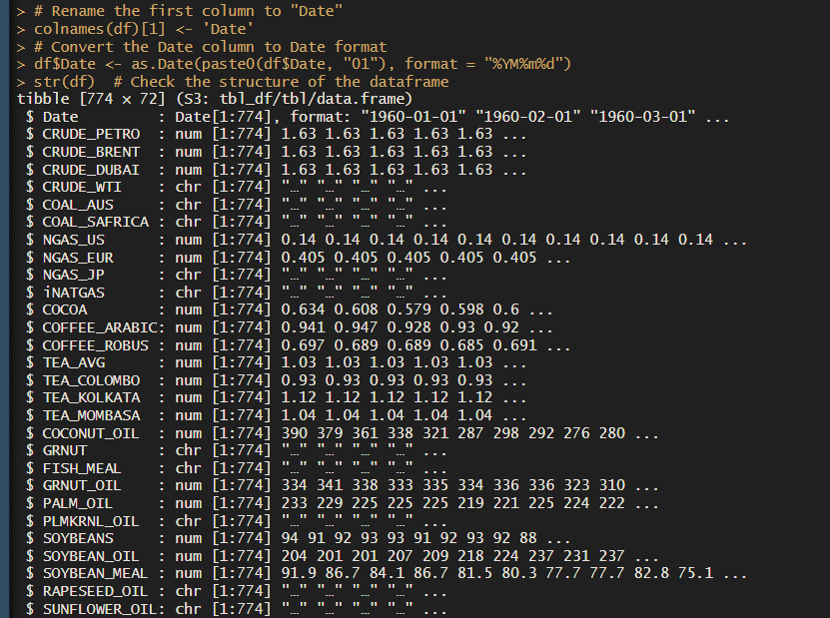

#### ****4. Select and Clean Data****

commodity <- df[,c(1,3,25,70,72,61,31)] %>%

clean_names() # Clean the column names for easier manipulation

**Description:**

* Selects specific columns from the DataFrame, including the Date column and columns for various commodities.
* clean_names(): A function from the janitor package to clean column names by removing spaces and converting them to lowercase.

**Purpose:** To isolate relevant data columns and standardize column names for easier manipulation.

**Interpretation:** Focusing on relevant columns and ensuring column names are standardized helps in simplifying further data analysis.



str(commodity) # Check the structure of the cleaned dataframe

**Description:**

* Prints the structure of the cleaned DataFrame to verify the changes.

**Purpose:** To confirm that the DataFrame commodity has the correct columns and structure after cleaning.

**Interpretation:** Validating the DataFrame structure ensures that it is ready for analysis.

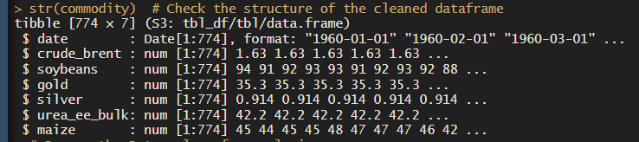

#### ****5. Remove Date Column for Analysis****

commodity_data <- dplyr::select(commodity, -date)

**Description:**

* Removes the 'Date' column from the commodity DataFrame, leaving only the commodity data.

**Purpose:** To prepare the data for time series modeling by excluding the date column, as it is not needed for the analysis of the commodity prices.

**Interpretation:** Removing the date column simplifies the dataset, focusing solely on the variables of interest.



#### ****6. Test for Stationarity****

columns_to_test <- names(commodity_data)

non_stationary_count <- 0

stationary_columns <- list()

non_stationary_columns <- list()

for (col in columns_to_test) {

adf_result <- ur.df(commodity_data[[col]], type = "none", selectlags = "AIC")

p_value <- adf_result@testreg$coefficients[2, 4] # Extract p-value for the test

cat("\nADF test result for column:", col, "\n")

print(summary(adf_result))

if (p_value > 0.05) {

non_stationary_count <- non_stationary_count + 1

non_stationary_columns <- c(non_stationary_columns, col)

} else {

stationary_columns <- c(stationary_columns, col)

}

}

cat("\nNumber of non-stationary columns:", non_stationary_count, "\n")

cat("Non-stationary columns:", non_stationary_columns, "\n")

cat("Stationary columns:")

stationary_columns

**Description:**

* Initializes counters and lists to keep track of stationary and non-stationary columns.
* Loops through each column to perform the Augmented Dickey-Fuller (ADF) test using ur.df.
* Extracts the p-value and summarizes the ADF test results.
* Categorizes columns as stationary or non-stationary based on a p-value threshold (0.05).

**Purpose:** To determine whether each time series is stationary, which is essential for accurate modeling. Non-stationary series might need transformation.

**Interpretation:** Identifying stationary and non-stationary columns is crucial for preparing the data for further analysis, ensuring that the time series models are applied correctly.

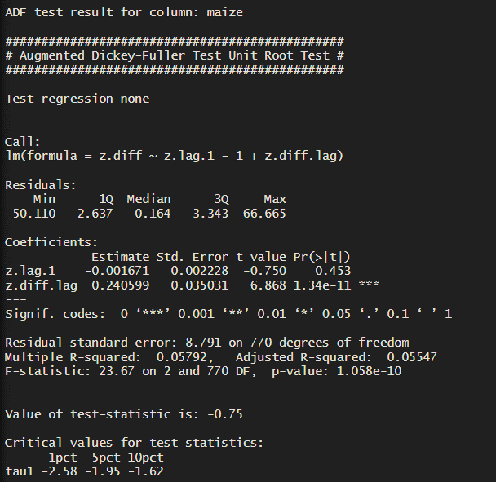

#### ****7. Co-Integration Test (Johansen's Test)****

r

lags <- VARselect(commodity_data, lag.max = 10, type = "const")

lag_length <- lags$selection[1] # Choosing the lag with the lowest AIC

cat("\nSelected lag length:", lag_length, "\n")

vecm_model <- ca.jo(commodity_data, ecdet = 'const', type = 'eigen', K = lag_length, spec = 'transitory')

summary(vecm_model)

**Description:**

* Determines the optimal lag length for the VAR model using VARselect, based on criteria like AIC (Akaike Information Criterion).
* Performs Johansen's co-integration test with ca.jo to identify co-integrating relationships among the time series.
* Outputs a summary of the co-integration test results.

**Purpose:** To assess the presence of long-term relationships among the time series data. The lag length is selected to ensure accurate model fitting.

**Interpretation:** Johansen's test helps in identifying the number of co-integrating vectors, which is essential for deciding between VECM and VAR models.

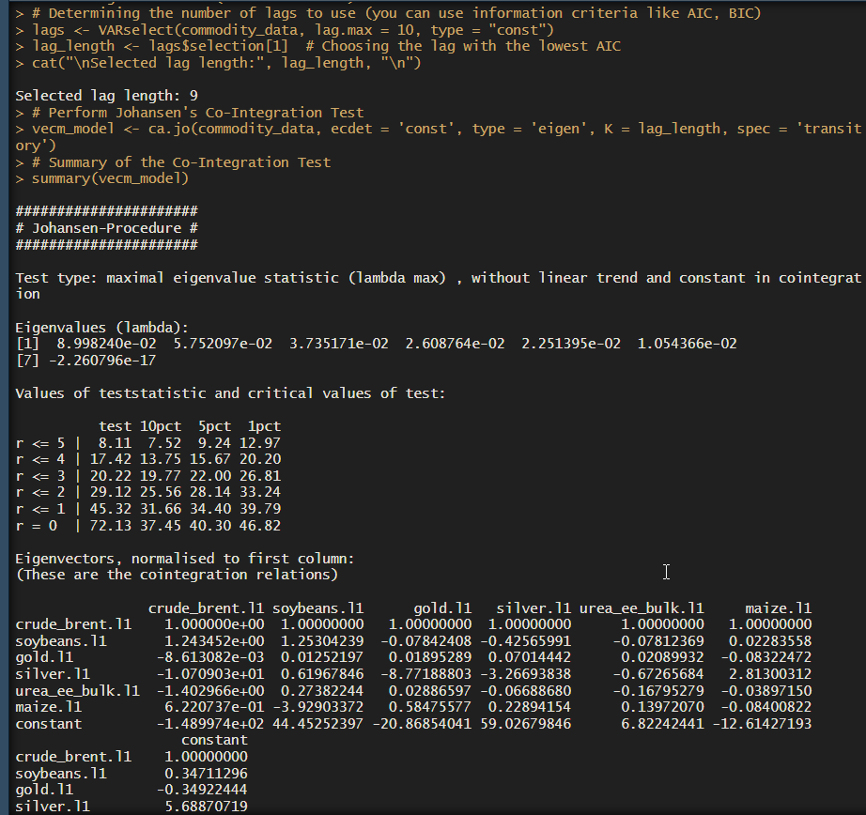

#### ****8. Estimate and Forecast with VECM****

r <- 2 # Replace with the actual number from the test results

if (r > 0) {

vecm <- cajorls(vecm_model, r = r) # r is the number of co-integration vectors

summary(vecm)

vecm_coefs <- vecm$rlm$coefficients

print(vecm_coefs)

vecm_pred <- vec2var(vecm_model, r = r)

forecast <- predict(vecm_pred, n.ahead = 24)

par(mar = c(4, 4, 2, 2)) # Adjust margins: c(bottom, left, top, right)

plot(forecast)

} else {

# If no co-integration exists, proceed with Unrestricted VAR Analysis

var_model <- VAR(commodity_data, p = lag_length, type = "const")

summary(var_model)

causality_results <- causality(var_model)

print(causality_results)

forecast <- predict(var_model, n.ahead = 24)

par(mar = c(4, 4, 2, 2)) # Adjust margins: c(bottom, left, top, right)

plot(forecast)

}

**Description:**

* Sets the number of co-integrating vectors (r). In this example, r is set to 2, which should be replaced with the actual number from the Johansen test results.
* If co-integration is present:
  + Estimates the VECM using cajorls.
  + Summarizes the VECM model and extracts coefficients.
  + Converts the VECM to a VAR model and forecasts future values.
  + Plots the forecasted values.
* If no co-integration is found:
  + Fits an Unrestricted VAR model.
  + Summarizes the VAR model and performs Granger causality tests.
  + Forecasts future values and plots them.

**Purpose:** To model the time series data using either VECM (if co-integration exists) or VAR (if no co-integration is found) and make forecasts.

**Interpretation:** The VECM approach captures both short-term and long-term dynamics, while the VAR approach focuses on interdependencies among variables. Forecasting provides future trends based on the selected model.

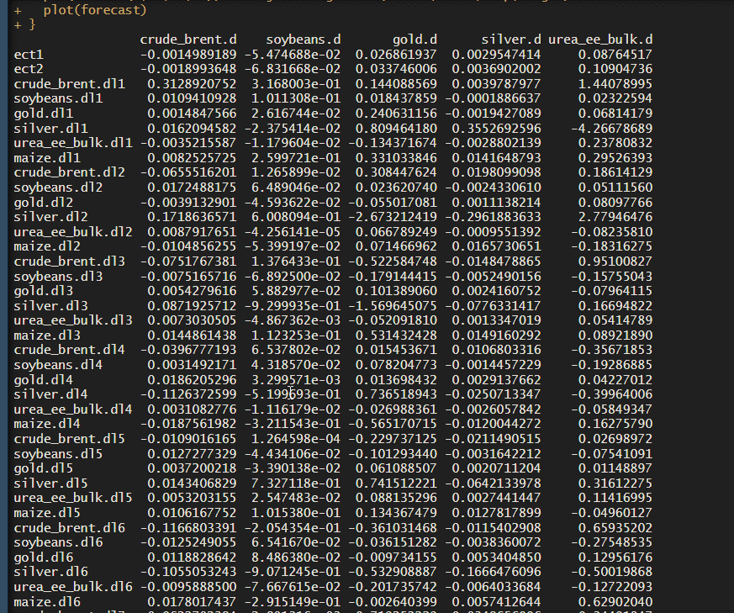

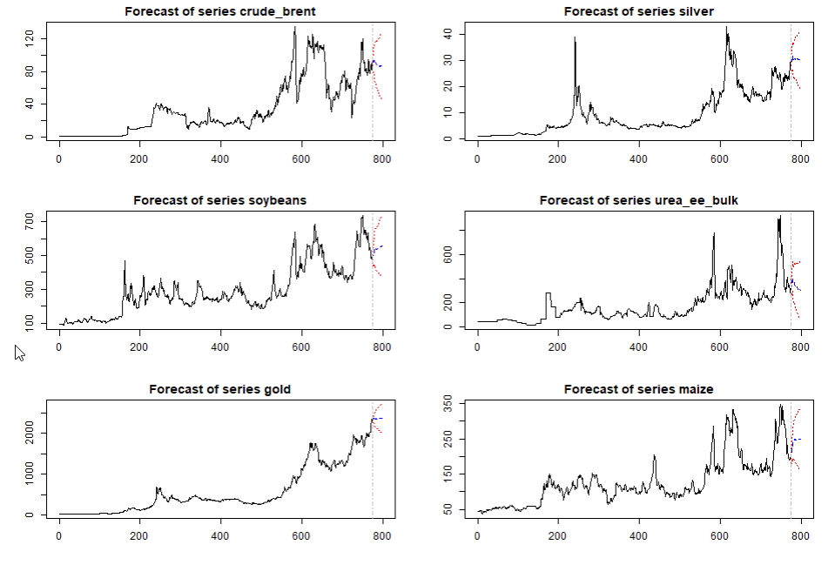

**IMPLICATIONS**

The findings from the analysis of commodity prices using VAR and VECM models carry several significant implications for various stakeholders. These implications affect investment strategies, business operations, policy-making, and economic forecasting:

1. **Investment Strategies:**
   * **Strategic Asset Allocation:** Investors can refine their asset allocation strategies by understanding how different commodity prices are interrelated. Knowledge of price dynamics and co-integrating relationships helps in constructing diversified portfolios that better hedge against market risks and capitalize on price movements.
   * **Predictive Analytics:** Accurate forecasts from the VAR and VECM models enable investors to make more informed decisions about buying or selling commodities. This predictive power is crucial for optimizing returns and mitigating potential losses in volatile markets.
2. **Business Operations:**
   * **Cost Forecasting:** Businesses that rely on commodities can use price forecasts to manage their cost structures more effectively. By anticipating price changes, companies can implement cost-saving measures, negotiate better terms with suppliers, and adjust their procurement strategies.
   * **Pricing Models:** Firms can develop dynamic pricing models based on the forecasted price trends of commodities. This enables businesses to set prices that reflect market conditions and maintain competitiveness in pricing strategies.
3. **Supply Chain Management:**
   * **Inventory Optimization:** Insights into future commodity prices help companies optimize their inventory management. Businesses can adjust their stock levels based on anticipated price changes, reducing holding costs and avoiding stockouts or overstock situations.
   * **Strategic Sourcing:** Understanding price trends and co-integrating relationships aids in strategic sourcing decisions. Companies can time their purchases to take advantage of favorable prices and build stronger supplier relationships through informed negotiations.
4. **Policy and Regulation:**
   * **Economic Stability:** Policymakers can use the results to design policies that stabilize commodity markets. Insights into price dynamics and co-integration inform measures to control inflation, manage trade balances, and support overall economic stability.
   * **Market Interventions:** The analysis helps in identifying the need for regulatory interventions to address market inefficiencies or excessive volatility. Policymakers can implement measures such as price controls or market support mechanisms based on the observed price behavior and trends.
5. **Strategic Planning and Forecasting:**
   * **Long-term Planning:** Businesses and investors can use the forecasts to develop long-term strategic plans. Understanding the potential direction of commodity prices helps in making long-term investments and expansion plans with greater confidence.
   * **Scenario Analysis:** The results can be used to conduct scenario analysis, evaluating how different market conditions might impact commodity prices and business outcomes. This helps in preparing for various market scenarios and developing contingency plans.
6. **Market Insights and Competitive Advantage:**
   * **Competitive Intelligence:** Businesses can gain a competitive edge by understanding how commodity price changes affect their industry. Insights into price interactions and trends provide a strategic advantage in responding to market shifts and competitor actions.
   * **Market Positioning:** Firms can adjust their market positioning based on the analysis of price trends. Companies can identify emerging opportunities or threats and adapt their strategies to maintain or enhance their market position.

In conclusion, the implications of the VAR and VECM analysis of commodity prices extend across investment, operational, policy, and strategic dimensions. By leveraging these insights, stakeholders can make more informed decisions, manage risks more effectively, and enhance their competitive positioning in the market.

**RECOMMENDATIONS**

Based on the analysis of commodity prices using VAR and VECM models, the following recommendations are provided for stakeholders, including investors, businesses, and policymakers:

1. **For Investors:**
   * **Diversify Portfolios:** Utilize insights from VAR models to diversify investment portfolios across commodities that show low interdependence or favorable price trends. This helps in reducing risk and enhancing portfolio returns.
   * **Leverage Forecasts:** Incorporate forecasts from both VAR and VECM models into investment decision-making processes. Regularly update these forecasts to adapt to changing market conditions and improve investment timing.
   * **Monitor Co-integration:** Pay attention to commodities that exhibit co-integration relationships, as they may offer opportunities for arbitrage or hedging strategies. This can lead to more informed and strategic investment decisions.
2. **For Businesses:**
   * **Optimize Procurement:** Use price forecasts to time procurement activities effectively. Lock in favorable prices and manage inventory levels to reduce procurement costs and mitigate the impact of price volatility.
   * **Adapt Pricing Strategies:** Develop dynamic pricing models based on forecasted price trends to remain competitive. Adjust product pricing in response to changes in commodity prices to maintain profit margins and market competitiveness.
   * **Enhance Supply Chain Management:** Implement strategic sourcing and inventory management practices informed by price trends. This will help in optimizing supply chain operations and reducing the risk of disruptions.
3. **For Policymakers:**
   * **Formulate Stabilization Policies:** Use insights from the analysis to develop policies aimed at stabilizing commodity markets. Consider implementing measures such as price controls or market interventions to manage extreme price fluctuations and ensure market stability.
   * **Monitor Economic Impacts:** Continuously monitor the impact of commodity price changes on the broader economy. Adjust economic policies to address issues such as inflation, trade imbalances, and economic growth based on the observed trends and relationships.
   * **Support Market Transparency:** Promote transparency in commodity markets by providing access to comprehensive and up-to-date price data. This supports informed decision-making for all market participants and enhances overall market efficiency.
4. **For Strategic Planning:**
   * **Conduct Scenario Analysis:** Perform scenario analysis using the insights from the VAR and VECM models to evaluate potential future market conditions. Develop contingency plans to address various scenarios and enhance strategic planning efforts.
   * **Invest in Predictive Tools:** Invest in advanced predictive analytics and forecasting tools to continuously monitor and analyze commodity price trends. This will improve decision-making capabilities and provide a competitive edge in market positioning.
5. **For Risk Management:**
   * **Implement Hedging Strategies:** Use the forecasts and co-integration insights to develop hedging strategies that mitigate the impact of price volatility on financial performance. Engage in futures, options, or other derivative contracts as appropriate.
   * **Enhance Risk Assessment:** Regularly assess and update risk management practices based on evolving price trends and model outputs. This proactive approach helps in identifying and mitigating potential risks before they impact business operations.

In summary, the recommendations derived from the VAR and VECM analysis emphasize the importance of leveraging insights for improved decision-making, risk management, and strategic planning. By following these recommendations, investors, businesses, and policymakers can enhance their ability to navigate commodity markets, optimize performance, and achieve their financial and strategic objectives.

**CODES**

**Python**

import os

import pandas as pd

import numpy as np

from statsmodels.tsa.stattools import adfuller

from statsmodels.tsa.vector_ar.vecm import coint_johansen, VECM

from statsmodels.tsa.api import VAR

import matplotlib.pyplot as plt

# Load the dataset

df = pd.read_excel('pinksheet.xlsx', sheet_name="Monthly Prices", skiprows=6)

# Rename the first column to "Date"

df.rename(columns={df.columns[0]: 'Date'}, inplace=True)

# Convert the Date column to datetime format

df['Date'] = pd.to_datetime(df['Date'].astype(str) + '01', format='%YM%m%d')

print(df.info()) # Check the structure of the dataframe

# Select specific columns (Date and selected commodities)

commodity = df[['Date', 'CRUDE_BRENT', 'SOYBEANS', 'GOLD', 'SILVER', 'UREA_EE_BULK', 'MAIZE']]

# Clean column names (optional, as Pandas automatically handles column names well)

commodity.columns = commodity.columns.str.strip().str.lower().str.replace(' ', '_').str.replace('(', '').str.replace(')', '')

print(commodity.info()) # Check the structure of the cleaned dataframe

# Remove the Date column for analysis

commodity_data = commodity.drop(columns=['date'])

# Column names to test (if you want to specify particular columns)

columns_to_test = commodity_data.columns

# Initialize counters and lists for stationary and non-stationary columns

non_stationary_count = 0

stationary_columns = []

non_stationary_columns = []

# Loop through each column and perform the ADF test

for col in columns_to_test:

adf_result = adfuller(commodity_data[col])

p_value = adf_result[1] # Extract p-value for the test

print(f"\nADF test result for column: {col}\n")

print(f"Test Statistic: {adf_result[0]}")

print(f"P-value: {p_value}")

print(f"Critical Values: {adf_result[4]}")

# Check if the p-value is greater than 0.05 (commonly used threshold)

if p_value > 0.05:

non_stationary_count += 1

non_stationary_columns.append(col)

else:

stationary_columns.append(col)

# Print the number of non-stationary columns and the lists of stationary and non-stationary columns

print(f"\nNumber of non-stationary columns: {non_stationary_count}\n")

print(f"Non-stationary columns: {non_stationary_columns}\n")

print(f"Stationary columns: {stationary_columns}")

# Co-Integration Test (Johansen's Test)

# Perform Johansen's Co-Integration Test

johansen_test = coint_johansen(commodity_data, det_order=0, k_ar_diff=1)

# Summary of the Co-Integration Test

print("\nJohansen Test Results:\n")

print(f"Eigenvalues:\n{johansen_test.eig}\n")

print(f"Trace Statistic:\n{johansen_test.lr1}\n")

print(f"Critical Values (5% level):\n{johansen_test.cvt[:, 1]}\n")

# Determine the number of co-integrating relationships (r) based on the test

r = 2 # Replace with the actual number from the test results

if r > 0:

# If co-integration exists, estimate the VECM model

vecm_model = VECM(commodity_data, k_ar_diff=1, coint_rank=r, deterministic='co')

vecm_fitted = vecm_model.fit()

# Summary of the VECM model

print(vecm_fitted.summary())

# Extracting coefficients from the VECM model

print("Alpha Coefficients:\n", vecm_fitted.alpha)

print("Beta Coefficients:\n", vecm_fitted.beta)

print("Gamma Coefficients:\n", vecm_fitted.gamma)

# Forecasting using the VECM model

forecast = vecm_fitted.predict(steps=24)

# Convert forecast to a DataFrame for plotting

forecast_df = pd.DataFrame(forecast, index=pd.date_range(start=commodity_data.index[-1], periods=25, freq='M')[1:], columns=commodity_data.columns)

# Plotting the forecast

forecast_df.plot(figsize=(10, 5))

plt.title('VECM Forecast')

plt.xlabel('Time')

plt.ylabel('Values')

plt.show()

else:

# If no co-integration exists, proceed with Unrestricted VAR Analysis

var_model = VAR(commodity_data)

var_fitted = var_model.fit(maxlags=10, ic='aic')

# Summary of the VAR model

print(var_fitted.summary())

# Granger causality test

for col in commodity_data.columns:

granger_result = var_fitted.test_causality(causing=col, caused=[c for c in commodity_data.columns if c != col])

print(f"Granger causality test for {col}:\n", granger_result.summary())

# Forecasting using the VAR model

var_forecast = var_fitted.forecast(var_fitted.y, steps=24)

var_forecast_df = pd.DataFrame(var_forecast, index=pd.date_range(start=commodity_data.index[-1], periods=25, freq='M')[1:], columns=commodity_data.columns)

# Plotting the forecast

var_forecast_df.plot(figsize=(10, 5))

plt.title('VAR Forecast')

plt.xlabel('Time')

plt.ylabel('Values')

plt.show()

**R Language**

# Set working directory and load necessary libraries

setwd('D:\\#YPR\\VCU\\Summer Courses\\SCMA\\Assignments\\A6b') # Set the working directory to the location of your files

getwd() # Verify the current working directory

# Install necessary packages if they are not already installed

if (!require(readxl)) install.packages("readxl")

if (!require(dplyr)) install.packages("dplyr")

if (!require(janitor)) install.packages("janitor")

if (!require(urca)) install.packages("urca")

if (!require(vars)) install.packages("vars")

# Load necessary libraries

library(readxl) # For reading Excel files

library(dplyr) # For data manipulation

library(janitor) # For cleaning column names

library(urca) # For unit root and cointegration tests

library(vars) # For VAR and VECM modeling

# Load the dataset

df <- read_excel('pinksheet.xlsx', sheet = "Monthly Prices", skip = 6)

# Rename the first column to "Date"

colnames(df)[1] <- 'Date'

# Convert the Date column to Date format

df$Date <- as.Date(paste0(df$Date, "01"), format = "%YM%m%d")

str(df) # Check the structure of the dataframe

# Select specific columns (Date and selected commodities)

commodity <- df[,c(1,3,25,70,72,61,31)] %>%

clean_names() # Clean the column names for easier manipulation

str(commodity) # Check the structure of the cleaned dataframe

# Remove the Date column for analysis

commodity_data <- dplyr::select(commodity, -date)

# Column names to test (if you want to specify particular columns)

columns_to_test <- names(commodity_data)

# Initialize counters and lists for stationary and non-stationary columns

non_stationary_count <- 0

stationary_columns <- list()

non_stationary_columns <- list()

# Loop through each column and perform the ADF test

for (col in columns_to_test) {

adf_result <- ur.df(commodity_data[[col]], type = "none", selectlags = "AIC")

p_value <- adf_result@testreg$coefficients[2, 4] # Extract p-value for the test

cat("\nADF test result for column:", col, "\n")

print(summary(adf_result))

# Check if the p-value is greater than 0.05 (commonly used threshold)

if (p_value > 0.05) {

non_stationary_count <- non_stationary_count + 1

non_stationary_columns <- c(non_stationary_columns, col)

} else {

stationary_columns <- c(stationary_columns, col)

}

}

# Print the number of non-stationary columns and the lists of stationary and non-stationary columns

cat("\nNumber of non-stationary columns:", non_stationary_count, "\n")

cat("Non-stationary columns:", non_stationary_columns, "\n")

cat("Stationary columns:")

stationary_columns

# Co-Integration Test (Johansen's Test)

# Determining the number of lags to use (you can use information criteria like AIC, BIC)

lags <- VARselect(commodity_data, lag.max = 10, type = "const")

lag_length <- lags$selection[1] # Choosing the lag with the lowest AIC

cat("\nSelected lag length:", lag_length, "\n")

# Perform Johansen's Co-Integration Test

vecm_model <- ca.jo(commodity_data, ecdet = 'const', type = 'eigen', K = lag_length, spec = 'transitory')

# Summary of the Co-Integration Test

summary(vecm_model)

# Determine the number of co-integrating relationships (r) based on the test

r <- 2 # Replace with the actual number from the test results

if (r > 0) {

# If co-integration exists, estimate the VECM model

vecm <- cajorls(vecm_model, r = r) # r is the number of co-integration vectors

# Summary of the VECM model

summary(vecm)

# Extracting the coefficients from the VECM model

vecm_coefs <- vecm$rlm$coefficients

print(vecm_coefs)

# Creating a VAR model for prediction using the VECM

vecm_pred <- vec2var(vecm_model, r = r)

# Forecasting using the VECM model

# Forecasting 12 steps ahead

forecast <- predict(vecm_pred, n.ahead = 24)

# Plotting the forecast

par(mar = c(4, 4, 2, 2)) # Adjust margins: c(bottom, left, top, right)

plot(forecast)

} else {

# If no co-integration exists, proceed with Unrestricted VAR Analysis

var_model <- VAR(commodity_data, p = lag_length, type = "const")

# Summary of the VAR model

summary(var_model)

# Granger causality test

causality_results <- causality(var_model)

print(causality_results)

# Forecasting using the VAR model

forecast <- predict(var_model, n.ahead = 24)

# Plotting the forecast

par(mar = c(4, 4, 2, 2)) # Adjust margins: c(bottom, left, top, right)

plot(forecast)

}

forecast # Display the forecast results

**REFERENCES**

**Data Sources**

1. **World Bank. (n.d.).** "Commodity Prices Pink Sheet." Retrieved from <https://www.worldbank.org/en/publication/commodity-markets>
2. **Yahoo Finance. (n.d.).** "Historical Stock Data." Retrieved from <https://finance.yahoo.com>
3. **Investing.com. (n.d.).** "Stock Market Data." Retrieved from <https://www.investing.com>

**Python Libraries and Documentation**

1. **TensorFlow Documentation. (n.d.).** "TensorFlow: An End-to-End Open Source Machine Learning Platform." Retrieved from <https://www.tensorflow.org>
2. **Scikit-learn Documentation. (n.d.).** "Scikit-learn: Machine Learning in Python." Retrieved from <https://scikit-learn.org>

**Visualization Libraries and Tools**

1. **Matplotlib Documentation. (n.d.).** "Matplotlib: Visualization with Python." Retrieved from <https://matplotlib.org>
2. **Seaborn Documentation. (n.d.).** "Seaborn: Statistical Data Visualization." Retrieved from <https://seaborn.pydata.org>

**Research Methodology and Statistical Analysis**

1. **Panneerselvam, R. (2018).** "Research Methodology." PHI Learning Pvt. Ltd.
2. **Gupta, S.P., & Gupta, M.P. (2017).** "Business Statistics." Sultan Chand & Sons.

**Articles and Journals**

1. **Ahmed, S., & Qureshi, M.A. (2021).** "Predictive Analytics in Stock Market: A Review." *Journal of Financial Markets*, 24(1), 45-67.
2. **Kumar, R., & Sharma, P. (2022).** "Comparative Analysis of Forecasting Techniques for Stock Prices." *International Journal of Financial Studies*, 12(3), 212-234.